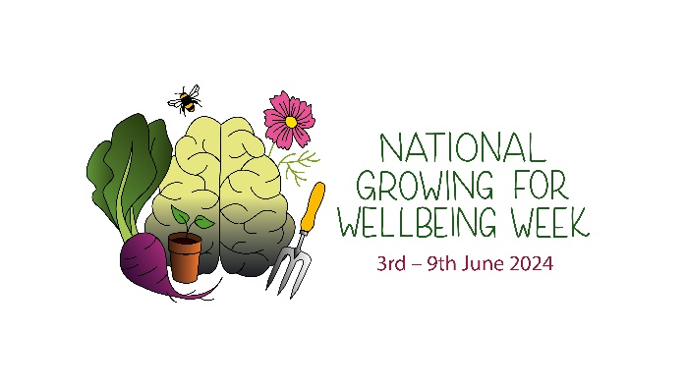
National Growing for Wellbeing Week is a UK-based campaign founded by mental health organisation; Life at No.27 in 2019. The week aims to promote, educate and celebrate horticultural therapy, nature connection and therapeutic conversations. Click here to visit the website.

The following toolkit provides suggested copy for social media and email communications. If you have any questions, please don’t hesitate to contact Annabelle.

Associated approved imagery and branding for social media can be downloaded here.

Suggested copy ideas:

Twitter | Instagram | LinkedIn
It’s @gyowellbeingwk with @lifeatno27; celebrating how learning to garden and being in nature can improve our wellbeing. Getting my hands in the soil and talking with friends, really helps.  #gyowellbeingwk | It’s @gyowellbeingwk with @lifeatno27; celebrating how learning to garden and being in nature can improve our wellbeing. Getting my hands in the soil and talking with friends, really helps me!  Does nature and playing with plants help you? If so, join the celebrations too!  #gyowellbeingwk | It’s National Growing for Wellbeing Week with @lifeatno27; celebrating how learning to garden and being in nature can improve our wellbeing. Getting my hands in the soil and talking with friends, really helps.  Does nature and playing with plants help you? If so, join the celebrations too!  #gyowellbeingwk  https://lifeatno27.com/national-growing-for-wellbeing-week/
1 in 4 adults and 1 in 8 children will experience mental ill health, having a variety of different therapeutic programmes available, including gardening, art, conversation means that everyone’s recovery is personalised and more effective; not one size fits all.  #gyowellbeingwk | 1 in 4 adults and 1 in 8 children will experience mental ill health, having a variety of different therapeutic programmes available, including gardening, art, conversation means that everyone’s recovery is personalised and more effective; not one size fits all.  #gyowellbeingwk | 1 in 4 adults and 1 in 8 children will experience mental ill health, having a variety of different therapeutic programmes available, including gardening, art, conversation means that everyone’s recovery is personalised and more effective; not one size fits all.  www.lifeatno27.com  #gyowellbeingwk
Watching a seed germinate and grow into a giant pumpkin or tomato plant, can show us how with a bit of love, nurturing, patience and time, all our dreams can grow. Even the smallest ones.  @gyowellbeingwk #gyowellbeingwk | Watching a seed germinate and grow into a giant pumpkin or tomato plant, can show us how with a bit of love, nurturing, patience and time, all our dreams can grow. Even the smallest ones.  What seeds and dreams are you growing this week?  @gyowellbeingwk #gyowellbeingwk | Watching a seed germinate and grow into a giant pumpkin or tomato plant, can show us how with a bit of love, nurturing, patience and time, all our dreams can grow. Even the smallest ones.  What seeds and dreams are you growing this week?  @lifeatno27 #gyowellbeingwk
As soon as we sow a seed, we are thinking weeks or months ahead. The positive prospects of what could come and be.  This experience can be affirming and life changing when you are in a dark place.  @gyowellbeingwk #gyowellbeingwk | As soon as we sow a seed, we are thinking weeks or months ahead. The positive prospects of what could come and be.  This experience can be affirming and life changing when you are in a dark place.  @gyowellbeingwk #gyowellbeingwk | As soon as we sow a seed, we are thinking weeks or months ahead. The positive prospects of what could come and be.  This experience can be affirming and life changing when you are in a dark place.  @lifeatno27 #gyowellbeingwk
Evidence shows that many of us feel safer and more comfortable to have honest, open and perhaps vulnerable conversations outside. We can feel more able, less restricted or judged.  Outdoor therapy, like that offered by @lifeatno27 can be the missing piece for some of us. | Evidence shows that many of us feel safer and more comfortable to have honest, open and perhaps vulnerable conversations outside. We can feel more able, less restricted or judged.  Outdoor therapy, like that offered by @lifeatno27 can be the missing piece for some of us.  @gyowellbeingwk #gyowellbeingwk | Evidence shows that many of us feel safer and more comfortable to have honest, open and perhaps vulnerable conversations outside. We can feel more able, less restricted or judged.  Outdoor therapy, like that offered by @lifeatno27 can be the missing piece for some of us.  @lifeatno27 #gyowellbeingwk
Take a moment to ground yourself, notice 3 things you can hear, 3 things you can see and 3 things you can touch. This mindful activity from @gyowellbeingwk, can really help reduce stress, circling thoughts and catastrophising thinking. | Take a moment to ground yourself… Step outside, notice 3 things you can hear, 3 things you can see and 3 things you can touch.  This mindful activity from @gyowellbeingwk, can really help reduce stress, circling thoughts and catastrophising thinking.  We can see the beauty in the world clearer too! | Take a moment to ground yourself… Step outside, notice 3 things you can hear, 3 things you can see and 3 things you can touch.  This mindful activity from @lifeatno27, can really help reduce stress, circling thoughts and catastrophising thinking.  We can see the beauty in the world clearer too!
According to @lifeatno27, using our senses when we choose plants and design our outdoor space, will enable us to create a more holistic space and lots of opportunities of therapeutic experiences.  Smelling *** really helps me feel ****  #gyowellbeingwk | According to @lifeatno27, using our senses when we choose plants and design our outdoor space, will enable us to create a more holistic space and lots of opportunities of therapeutic experiences.  Smelling *** really helps me feel ****. What plants make you feel calm or happy?  #gyowellbeingwk @gyowellbeingwk | According to @lifeatno27, using our senses when we choose plants and design our outdoor space, will enable us to create a more holistic space and lots of opportunities of therapeutic experiences.  Smelling *** really helps me feel ****. What plants make you feel calm or happy?  #gyowellbeingwk  Find out more about sensory planting from them here: https://lifeatno27.com/2023/05/09/sensory-garden-design-my-approach/
I’ve just received the @gyowellbeingwk Activity Resource Pack and it’s full of so many fun activities.  I can’t wait to try ****  Get yours: https://lifeatno27.com/national-growing-for-wellbeing-week/ | I’ve just received the @gyowellbeingwk Activity Resource Pack from @lifeatno27, and it’s full of so many fun activities.  I can’t wait to try **** this week!  Get yours: https://lifeatno27.com/national-growing-for-wellbeing-week/ | I’ve just received the #GYOWellbeingWk Activity Resource Pack from @lifeatno27, and it’s full of so many fun activities.  I can’t wait to try **** this week!  Get yours: https://lifeatno27.com/national-growing-for-wellbeing-week/

